**ADA LAB WEEK 6**

**Zayd Ahmed**

**1BM21CS254**

**25/07/23**

**Q1) Knapsack problem using C.**

#include <stdio.h>

int v[10][10];

int p[10],w[10];

int n,m;

int max(int x, int y){

if(x>y)

return x;

else

return y;

}

void knapsack(){

int x[10];

for(int i=0;i<=n;i++){

for(int j=0;j<=m;j++){

if(i==0 || j==0){

v[i][j]=0;

}

else if(j-w[i]<0){

v[i][j]=v[i-1][j];

}

else{

v[i][j]=max(v[i-1][j],v[i-1][j-w[i]]+p[i]);

}

}

}

printf("Output is:\n");

for(int i=0;i<=n;i++){

for(int j=0;j<=m;j++){

printf("%d ",v[i][j]);

}

printf("\n");

}

printf("Highest profit= %d\n",v[n][m]);

int j=m;

int i=n;

printf("Optimal solution\n");

while(j>0){

if(v[i][j]!=v[i-1][j]){

x[i]=1;

j=j-w[i];

}

else{

x[i]=0;

}

}

for (i = 1; i <= n; i++){

printf("%d\t", x[i]);

}

}

int main(){

printf("enter the number of items:\t");

scanf("%d",&n);

printf("enter the max capacity of knapsack:\t");

scanf("%d",&m);

printf("enter the weights of all items:\n");

for(int i=1;i<n;i++){

scanf("%d",&w[i]);

}

printf("enter the profits of all items:\n");

for(int i=1;i<n;i++){

scanf("%d",&p[i]);

}

knapsack();

return 0;

}

**Output:**

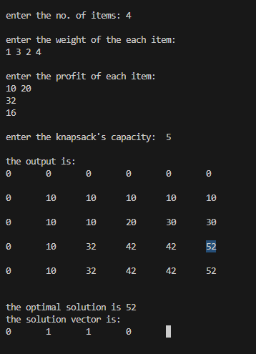

**Q2) Floyds algorithm to find shortest path among nodes.**

#include<stdio.h>

int min(int a,int b) {

if(a<b) return(a);

else return(b);

}

void floyds(int p[10][10],int n) {

int i,j,k;

for (k=1;k<=n;k++)

{

for (i=1;i<=n;i++)

{

for (j=1;j<=n;j++)

p[i][j]=min(p[i][j],p[i][k]+p[k][j]);

}

}

}

int main() {

int p[10][10],w,n,e,u,v,i,j;

printf("\n Enter the number of vertices and edges:");

scanf("%d %d",&n,&e);

for (i=1;i<=n;i++) {

for (j=1;j<=n;j++)

{

if(i==j)

p[i][j]=0;

else

p[i][j]=999;

}

}

for (i=1;i<=e;i++) {

printf("\nEnter the end vertices of edge %d with its weight:\n",i);

scanf("%d %d %d",&u,&v,&w);

p[u][v]=w;

}

printf("\n Matrix of input data:\n");

for (i=1;i<=n;i++) {

for (j=1;j<=n;j++)

printf("%d \t",p[i][j]);

printf("\n");

}

floyds(p,n);

printf("\n Transitive closure:\n");

for (i=1;i<=n;i++) {

for (j=1;j<=n;j++)

printf("%d \t",p[i][j]);

printf("\n");

}

return 0;

}

**Output:**

